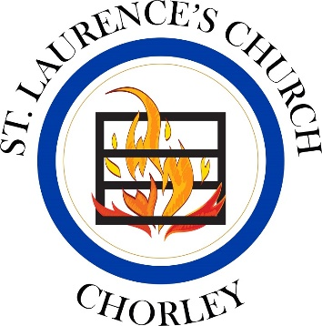
Record Card for St. Laurence’s School
& St Michael’s School

Spring Term 2024

Please look after this card and present it for signing at the end of the service you attend. You will need to hand it in to Fr Neil or email it to pa@stlaurencechorley.co.uk when you submit your faith reference form by January of your admissions year. If you have any queries at any time, please don’t hesitate to call Fr. Neil (07980 872203/rector@stlaurencechorley.co.uk). We are delighted you are worshipping with us!

Family Surname:

Child’s Name:

Date of Birth:

Parent Signature:

Parent Signature:

Issued by: Fr. Neil

Date Issued: 23.12.23

Saturday/Sunday Date  2024  Only one service per week counts. | Parent signature (not pre-signed please) | Church Authorisation
6th or 7th January

13th or 14th January

20th or 21st January

27th or 28th January

3rd or 4th February

17th or 18th February
24th or 25th February
2nd or 3rd March
9th or 10th March
16th or 17th March

23rd or 24th March
30th or 31st March
Please note there is no 5pm service on 30th March

