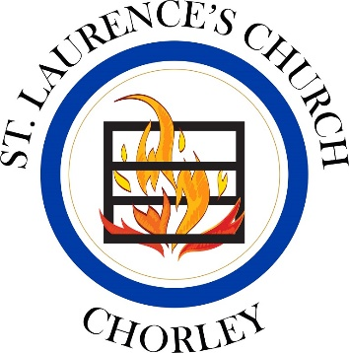
Record Card for St. Laurence’s School
& St Michael’s School

Summer Term 2022

Please look after this card and present it for signing at the end of the service you attend. You may need to hand it in to the school with your faith reference form by January of your admissions year. If you have any queries at any time, please don’t hesitate to call Fr. Neil (07980 872203/rector@stlaurencechorley.co.uk). We are delighted you are worshipping with us!

Name of Child:

Date of Birth:

Parent Signature:

Parent Signature:

Issued by: Fr. Neil

Date Issued: 23.4.22

Saturday/Sunday Date  2022  Only one service per week counts. | Parent signature (not pre-signed please) | Church Authorisation
23rd or 24th April
(*24th April 9.30am at St George’s church only)
30th April or 1st May
7th or 8th May
14th or 15th May
21st or 22nd May
28th or 29th May
4th or 5th June
11th or 12th June
18th or 19th June
25th or 26th June
Saturday/Sunday Date  2022  Only one service per week counts | Parent signature (not pre-signed please) | Church Authorisation
2nd or 3rd July

9th or 10th July
16th or 17th July
23rd or 24th July
31st July at 10.30am only
7th August at 10.30am only
14th August at 10.30am only

21st August at 10.30am only

28th August at 10.30am only

