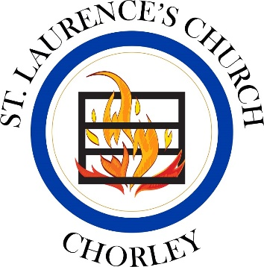
Record Card for St. Michael’s School

Lent Term 2022

Please look after this card and present it for signing at the end of the service you attend. You may need to hand it in to the school with your faith reference form by January of your admissions year. If you have any queries at any time, please don’t hesitate to call Fr. Neil (07980 872203/rector@stlaurencechorley.co.uk). We are delighted you are worshipping with us!

Name of Child:

Date of Birth:

Parent Signature:

Parent Signature:

Issued by:

Date Issued:

Saturday/Sunday Date  2022  Only one service per week counts | Parent signature (not pre-signed please) | Church Authorisation
2nd January
(11am service only)
8th or 9th January
15th or 16thJanuary
22nd or 23rd January
29th or 30th January
5th or 6th February
12th or 13th February
19th or 20th February
26th or 27th February
5th or 6th March
Saturday/Sunday Date  2022  Only one service per week counts | Parent signature (not pre-signed please) | Church Authorisation
12th or 13th March
19th or 20th March
26th or 27th March
2nd or 3rd April
9th or 10th April
17th April

