A Blue Christmas Reflection

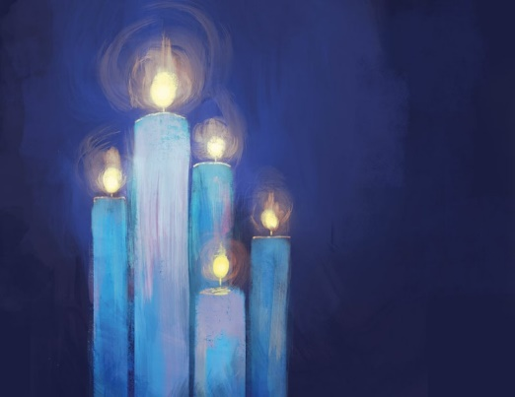

Background

We're very conscious that this time of year is a time of great excitement and joy for some, but for others, it is a time of intense loneliness and pain. There is pressure on us to ‘join the celebrations’ (even though they will be different this year). Sometimes we are just not in that place. Perhaps that is because of bereavement; perhaps it may be that we are living with depression or anxiety. It may be that we are struggling financially, and we can’t afford the basic necessities of life. This resource is offered in the hope it will help us focus on the true meaning of the birth of Jesus who brought light into a world of darkness.
You may wish to light a candle or have a cross to hold as you reflect and pray. You may like to prepare some music to reflect with as we pray.
Jesus said “I am the light of the world. Whoever follows me will never walk in darkness, but will have the light of life” (John 8:12)
Opening Prayer

Lord,
in the beginning, when all was very dark, you said:
let there be light. And there was light and life throughout the universe.

And when the human race was exhausted, tired and weary, in the darkness of anxiety, confusion and sin, into that darkness you came as light in Jesus Christ.
God became a human being among us all. Once again it is dark. Not just dark at midnight but dark in ourselves: dark with doubt, dark with fear and uncertainty, Dark with confusing and conflicting voices in our ears.

Come, light of Life, lighten the darkness in our lives with your mighty word of love.

Lighten our hearts with the joy of your promised coming. Lighten our world with the hope that faith in you brings.

The Word of the Lord

Luke 2: 1-7
About that time Caesar Augustus ordered a census to be taken throughout the Empire. This was the first census when Quirinius was governor of Syria. Everyone had to travel to his own ancestral hometown to be accounted for. So Joseph went from the Galilean town of Nazareth up to Bethlehem in Judah, David’s town, for the census. As a descendant of David, he had to go there. He went with Mary, his fiancée, who was pregnant. While they were there, the time came for her to give birth. She gave birth to a son, her firstborn. She wrapped him in a blanket and laid him in a manger, because there was no room in the hostel.

Reflection

Let us consider what that first Christmas was really like. Mary and Joseph knew the pain of rejection. There was no room in the inn. The Son of God was not born into a royal palace but into poverty and isolation. The real Christmas is very far from the snowy depictions on Christmas cards. Perhaps we need to paint our own picture of Christmas. What does Christmas really look like for you? Why not try to draw it on paper or in your head? The Bible reading describes what the birth of Jesus was actually like.

Christians believe that Jesus brought light into a world of darkness. The darkness wasn't removed however, it's just that the light is stronger and more powerful. And if we find ourselves sitting in the darkness at the moment, that is okay. Jesus came to bring warmth and light to that darkness, to our darkness, whatever our darkness feels like. He inhabits that space with us now. So we can turn to Him in confidence. We are not alone.

Perhaps in the silence focus on the candle you have lit; perhaps its light and warmth can remind you of the presence of Jesus sitting with us in our darkness.
A poem

The pain of bereavement is even more intense at Christmas, especially if this is the first Christmas without a loved one. This poem may help us to articulate how we are feeling.
For Grief - John O’Donohue

When you lose someone you love,
your life becomes strange,
the ground beneath you gets fragile,
your thoughts make your eyes unsure;
and some dead echo drags your voice down
where words have no confidence.
Your heart has grown heavy with loss;
and though this loss has wounded others too,
no one knows what has been taken from you
when the silence of absence deepens.

Flickers of guilt kindle regret
for all that was left unsaid or undone.

There are days when you wake up happy;
again inside the fullness of life,
until the moment breaks
and you are thrown back
onto the black tide of loss.

Days when you have your heart back,
you are able to function well
until in the middle of work or encounter,
suddenly with no warning,
you are ambushed by grief.

It becomes hard to trust yourself.
all you can depend on now is that
sorrow will remain faithful to itself.
More than you, it knows its way
and will find the right time
to pull and pull the rope of grief
until that coiled hill of tears
has reduced to its last drop.

Gradually, you will learn acquaintance
with the invisible form of your departed;
and, when the work of grief is done,
the wound of loss will heal
and you will have learned
to wean your eyes
from that gap in the air
and be able to enter the hearth
in your soul where your loved one
has awaited your return
all the time.

As you cherish your memories or hold on to your hopes for better times, why not play your piece of music for reflection here? Something that is rather beautiful, and combines the theme of Christmas with simplicity, is the carol “In the bleak midwinter.” Or there may be a piece of music that holds special memories for you.

Prayer

Our God,
we gather together in the bleak midwinter.
Those who have much to thank you for,
who rejoice in your goodness,
and those who look out on a landscape of broken dreams and hardly dare to hope for Good News.
Those whose hearts and homes are full of Christmas joy, and those whose Christmas cards show only ice and snow – not a robin in sight.
Those who anticipate celebration with loved ones,
and those who dread the season of togetherness –
for we are told that hearts are not supposed to break at Christmas.
We come as we are,
with our griefs and our joys,
and together, trembling,
we hope to hear the angels sing.
We hope for God With Us.
Loving God, come to us now, as you have come to your people in every age, as we gather our thoughts in the words that the adult Christ taught us:
Our Father…

The Blessing

To men and women crying out in darkness, pain and loneliness, Christ comes, at one with us, our Saviour, healer and friend.

May God the Father keep us in all our days.
May God the Son shield us in all our ways.
May God the Spirit bring us healing and peace.
May God the Holy Trinity drive all darkness from us and pour upon us blessing and light. Amen.

